Name

Mathematics Stage 5 Paths
Set Notation and Conditional Probability

Book 1 |  | Version: 261007  Feedback:  https://MrDingMaths.com
Contents
Syllabus Content 2
Learning Intention 3

Syllabus Content
MA5-PRO-P-01 solves problems involving Venn diagrams, 2-way tables and conditional probability
Solve problems involving Venn diagrams and 2-way tables
- Define a set as a collection of distinct objects
- Use Venn diagrams, set language and notation for events, including $\overline{A}$ (or $A^{'}$ or $A^{c}$) for the complement of an event $A$, $A∩B$ for '$A$ and $B$' (the intersection of events $A$ and $B$) and $A∪B$ for '$A$ or $B$' (the union of events $A$ and $B$) and recognise mutually exclusive events
Use the language, 'if … then', 'given', 'of' and 'knowing that', to examine conditional statements and identify common mistakes in interpreting the language
- Calculate the probabilities of events where a condition restricts the sample space
- Describe the effect of a given condition on the sample space
- Identify conditional statements used in descriptions of chance situations
- Explain the validity of conditional statements when describing chance situations, referring to dependent and independent events
- Identify and explain common misconceptions relating to chance experiments
Describe mutually and non-mutually exclusive events using specific language and calculate related probabilities
- Explain the difference between mutually exclusive and non-mutually exclusive events
- Describe compound events using the terms inclusive or and exclusive or
- Describe non-mutually exclusive events using the terminology and, inclusive or and exclusive or
- Describe events using the terms at least, at most, not and and
- Calculate the probability of compound events using strategies including Venn diagrams and 2-way tables

Set Notation

- Sets
A set is a collection of elements (objects).
We use { } to represent a set. Each element is separated by commas.
Sets have no repeated elements and no order.
The empty set has no elements, denoted in set notation as: $∅$

- Interpret set notation.
“$x$ is the set of numbers 7, 3, 2, 14”:  $$x=\left\{7, 3, 2, 14\right\}$$ | “$y$ is the set of numbers 6, 2, 2, and 7”:  $y=\left\{6, 2, 7\right\}$
Use set notation to list the elements of each of these sets.
- $A=${even numbers between 10 and 20 inclusive} | - $B=$ {days of the week}
- $C=${letters in the word “integer”} | - $D=$ {negative real square numbers}

- Element of Symbol
$a ∈ X$ means $a$ is included in set $X$.
“$a$ is an element of $X=\left\{a, b, c\right\}$”
$$a∈X$$

- Interpret element of symbol.
✖  $$4∉\left\{1,2,3\right\}$$ | ✔  $$2∈\left\{1,2,3\right\}$$ |  | ✔  $$dog∈\left\{cat, dog\right\}$$ |  | ✔  $$32.5∈R$$ |  | ✖  $$\sqrt{-3}∉R$$
Write the correct symbol, $∈$ or $∉$.

4 …… $\left\{1, 2, 3\right\}$ |  | 1 …… {12, 13, 15} |  | $\sqrt{5}$ …… $R$ |  | red …… {blue, black}

- Number of Elements
$n\left(A\right)$ or $\left|A\right|$ represents the number of elements inside set $A$.

- Interpret number of elements notation.
$$A=\left\{2,5,6,11\right\} \\ n\left(A\right)=4$$ | $$X=\left\{dog,cat,wednesday\right\} \\ n\left(X\right)=3$$ |  | $$S=\left\{even prime numbers\right\} \\ n\left(A\right)=1$$
Determine the number of elements in these sets.
- $A=\left\{9,8,23,77,-2\right\}$  $n\left(A\right)=$ |  | - $B=${months of the year}  $\left|B\right|=$
- $S=${letters in the word “integer”}  $\left|S\right|=$ |  | - $C=$ {prime numbers between 1 and 10}  $n\left(C\right)=$

- Universal Sets and The Complement
$U$ or $ξ$is the universal set that contains all elements we’re considering.
$\bar{A}$, $A'$ or $A^{c}$ represents the complement of set $A$.
The complement contains all elements that are in the universal set $U$ but are NOT in set $A$.
$A$ and $A^{'}$ together make up the universal set.

- Interpret universal sets and complement sets.
$$U=\left\{Integers between 0 and 10, inclusive\right\}$$  $=\left\{0, 1, 2, 3, 4, 5, 6, 7, 8, 9, 10\right\}$  $$A=\left\{Even integers\right\}$$  $=\left\{0, 2, 4, 6, 8, 10\right\}$  $$A^{'}=\left\{Not even integers\right\}$$  $=\left\{1, 3, 5, 7, 9\right\}$ | $$ξ=\left\{Integers between 0 and 10, inclusive\right\}$$  $=\left\{0, 1, 2, 3, 4, 5, 6, 7, 8, 9, 10\right\}$  $$A=\left\{Multiples of 3\right\}$$  $=\left\{0, 3, 6, 9\right\}$  $$A^{c}=\left\{Not multiples of 3\right\}$$  $=\left\{1, 2, 4, 5, 7, 8, 10\right\}$
List the elements for these sets, given the universal set.
- $U=\left\{days of the week\right\}$  $A=\left\{weekdays\right\}$  $A^{'}=$ | - $U=\left\{square numbers up to 100, inclusive\right\}$  $B=\left\{multiples of 5\right\}$  $B^{'}=$
- $ξ=\left\{Factors of 12\right\}$  $A=\left\{even factors\right\}$  $A^{c}=$ | - $ξ=\left\{Multiples of 4 up to 28, inclusive\right\}$  $A=\left\{odd multiples\right\}$  $\overline{A}=$

- Subsets
$A$ is a subset of $B$ if every element in $A$ is also in $B$.
“A is a subset of B”
$$A⊆B$$
- Every set is a subset of itself: A ⊆ A
- Empty set is subset of every set: ∅ ⊆ A
- A ⊂ B means A ⊆ B AND A ≠ B

- Identify subsets.
✖  A = {1, 3, 7}  B = {1, 3, 5}  $$A⊄B$$ | ✔  A = {1, 3}  B = {1, 3, 5}  $$A⊆B$$ |  | ✔  A = {R, B, G}  B = {R}  $$B⊆A$$ | ✔  X = {4, 2, 8, 6}  Y = {2, 4, 6, 8}  $$X⊆Y$$  $$Y⊆X$$ |  | ✖  X = {2, 4, 0}  Y = {2, 4, 6, 8}  $$X⊄Y$$
Write the correct symbol $⊆$ or $⊄$ to relate the two sets.
- A = {2, 4}  B = {1, 2, 3, 4, 5} |  | - A = {a, c}  B = {a, b, d} |  |  | - A = {real numbers $R$}  B = {integers $Z$}
- X = {3, 4, 5}  Y = {5, 3} |  | - A = {x, y, z}  B = {z, y, x} |  |  | - H = {2, 3}  K = {6}

- Intersection of Sets
The intersection of sets $A$ and $B$ are the set of elements that are both in $A$ and in $B$.
“Intersection of A and B”
$$A∩B$$

- Interpret intersections of sets.
A = {1, 3, 5, 7}  B = {3, 5, 9, 11}  A ∩ B = {3, 5} | C = {red, blue, green}  D = {blue, green, yellow}  C ∩ D = {blue, green} | E = {2, 4, 6}  F = {1, 3, 5}  E ∩ F = $∅$
Identify the intersection of these sets.
A = {1, 2, 3, 5, 8}  B = {2, 3, 4, 7} | C = {d, b, c, a}  D = {c, d, e, f} | C = {red, green, blue}  D = {green, orange, purple}

- Mutually Exclusive or Disjoint Sets
Two sets $A$ and $B$ are mutually exclusive (or disjoint) if they have no elements in common.
The intersection of $A$ and $B$ is an empty set.
$$A∩B=∅$$

- Identify disjoint/mutually exclusive sets.
Not mutually exclusive  A = {1, 3, 7}  B = {1, 5} | Mutually  exclusive  A = {1, 3, 7}  B = {2, 5} |  | Mutually  exclusive  A = {R, B, G}  B = {Y} | Mutually  exclusive  X = {positive}  Y = {negative} |  | Not mutually exclusive  X = {5, 6, 7}  Y = {1, 7, 12}
Identify which of these pairs of sets are mutually exclusive.
- A = {x, y}  B = {a, b} |  | - A = {a, c}  B = {a, b, d} |  |  | - A = {real numbers $R$}  B = {integers $Z$}
- X = {odd numbers}  Y = {even numbers} |  | - A = {prime numbers}  B = {multiples of 3} |  |  | - H = {humans}  K = {mammals}

- Union of Sets
The union of sets $A$ and $B$ are the set of elements that are in either $A$ or in $B$.
“Union of A and B”
$$A∪B$$

- Interpret unions of sets.
A = {1, 3}  B = {2, 3, 6}  A ∪ B = {1, 2, 3, 6} | C = {red, blue}  D = {blue, green}  C ∪ D = {red, blue, green} | E = {a, b}  F = {c, d}  E ∪ F = {a, b, c, d}
Identify the union of these sets.
A = {1, 2}  B = {3, 4} | C = {1, 2, 3}  D = {3, 4, 5} | C = {1, 2, 3}  D = {1, 2, 3}
A = {1, 2}  B = {1, 2, 3, 4} | C = {red, blue}  D = {green, blue, yellow} | C = {1, 2, 3, 4}  D = {4, 1, 7, 5}

- Example interpret set notation.
$$Universal set U = \{1, 2, 3, 4, 5, 6, 7, 8, 9, 10\}$$
$$Set A = \{2, 4, 6, 8\}$$
$$Set B = \{1, 2, 3, 4\}$$
$$Set C = \{5, 7, 9\}$$
For each question, write the meaning in English and give the answer.
- A ∪ B  Elements in either A or B = {1, 2, 3, 4, 6, 8} | - A ∩ B  Elements in both A and B = {2, 4}
- B ∪ C  Elements in either B or C = {1, 2, 3, 4, 5, 7, 9} | - A ∩ C  Elements in both A and C = ∅
- n(A)  Number of elements in A = 4 | - |C|  Number of elements in C = 3
- n(A ∪ B)  Number of elements in A or B = 6 | - A'  Complement of A = {1, 3, 5, 7, 9, 10}
- $\overline{B}$  Complement of B = {5, 6, 7, 8, 9, 10} | - Which sets are mutually exclusive?  A and C
True or false?
- A ⊆ B?  A subset of B? False.  (6 and 8 are in A but not in B) | - B ⊆ A?  B subset of A? False.  (1 and 3 are in B but not in A)
- {2, 4} ⊆ A?  {2, 4} subset of A? True.  (both 2 and 4 are elements of A) | - B ⊆ U?  B subset of the universal set? True.
Find the following by writing out each set combination separately.
- (A ∪ B) ∩ C  {1, 2, 3, 4, 6, 8} ∩ {5, 7, 9} = ∅ | - A ∩ B'  {2, 4, 6, 8} ∩ {5, 6, 7, 8, 9, 10} = {6, 8}
- (A ∪ C)'  {2, 4, 5, 6, 7, 8, 9}' = {1, 3, 10} | - n(A ∪ C)'  3

Foundation
- Geri asks 10 students in her class to name their favourite colour. Geri writes the results as set A. A = {green, purple, pink, red, blue, red, red, green, orange, red}.
Explain the mistake that Geri has made.

Sets cannot contain duplicate elements - "red" appears 4 times
- Write down the following sets by listing their members.
  - Odd positive integers less than 10.
{1, 3, 5, 7, 9}
  - The first six positive multiples of 6.
{6, 12, 18, 24, 30, 36}
  - The numbers on a die.
{1, 2, 3, 4, 5, 6}
  - The factors of 20.
{1, 2, 4, 5, 10, 20}

- List the elements of each of these sets. Use correct set notation.
  - X = {multiples of 7 between 20 and 40}
X = {21, 28, 35}
  - Y = {seasons in a year}
Y = {spring, summer, autumn, winter}
  - Z = {letters in the word "science"}
Z = {s, c, i, e, n}

- ξ = {2, 4, 6, 8, 10, 12, 14},
A = {2, 4, 8, 12}.
Write down the elements of A'.
A' = {6, 10, 14}
- A = {10, 11, 12, 13, 14, 15},
B = {12, 13, 14}.
List the elements of A ∩ B.
A ∩ B = {12, 13, 14}
- A = {red, white, blue},
B = {green, red, yellow, black}.
List the elements of A ∩ B.
A ∩ B = {red}
- If A = {1, 3, 5}, B = {3, 4} and E = {1, 2, 3, 4, 5}, find:
  - |A|
  - |B|
|A| = 3
|B| = 2

- ξ = {numbers from 1 to 50},
A = {odd numbers},
B = {even numbers},
C = {multiples of 10},
D = {square numbers}.
  - List all the elements of set D.
D = {1, 4, 9, 16, 25, 36, 49}
  - List all the elements that are in both set B and set D.
B ∩ D = {4, 16, 36}
  - Explain why there are no elements that are listed in both set A and set C.
All multiples of 10 are even, but A contains only odd numbers
  - List the elements that are in set C or D or both.
C ∪ D = {1, 4, 9, 10, 16, 20, 25, 30, 36, 40, 49}

- A = {factors of 12}, B = {factors of 30}.
  - List the elements of set A.
A = {1, 2, 3, 4, 6, 12}
  - List the elements of set B.
B = {1, 2, 3, 5, 6, 10, 15, 30}
  - Which numbers are in both set A and set B?
A ∩ B = {1, 2, 3, 6}

- Mateusz and Hannah are writing down as many three-letter words beginning with 't' as possible in 30 seconds.
M = {tab, tan, tam, the, tea, ten},
H = {tap, tax, tan, the, ten}.
  - List the elements of M ∪ H.
M ∪ H = {tab, tan, tam, the, tea, ten, tap, tax}
  - Describe what M ∪ H tells you.

b) All three-letter words beginning with 't' that either student wrote
- ξ = {1, 2, 3, 4, 5, 6, 7, 8, 9, 10},
A = {2, 4, 6, 8, 10},
B = {5, 10},
C = {2, 3, 5, 7}. Write down the elements of each of these sets.
  - A ∪ B
A ∪ B = {2, 4, 5, 6, 8, 10}
  - A ∪ C
A ∪ C = {2, 3, 4, 5, 6, 7, 8, 10}
  - B ∪ C
B ∪ C = {2, 3, 5, 7, 10}

Development
- X = {multiples of 5 between 12 and 33},
Y = {even numbers}.
List the elements of X ∩ Y.
X = {15, 20, 25, 30}, Y = {even numbers}
X ∩ Y = {20, 30}
- ξ = {multiples of 5 between 1 and 49},
A = {multiples of 3},
B = {multiples of 2}.
  - Write down the elements of A ∪ B.
  - Write down the elements of A ∩ B.
ξ = {5, 10, 15, 20, 25, 30, 35, 40, 45}
A ∪ B = {10, 15, 20, 30, 40, 45}
A ∩ B = {30}
- ξ = {e, g, h, m, n, p, s, t},
A = {h, p, s, t},
B = {e, g, h, m, p, t}.
Write down the elements of each of these sets.
  - A'
A' = {e, g, m, n}
  - B'
B' = {n, s}
  - (A ∩ B)'
A ∩ B = {h, p, t}, so (A ∩ B)' = {e, g, m, n, s}
  - (A ∪ B)'
A ∪ B = {e, g, h, m, p, s, t}, so (A ∪ B)' = {n}
- ξ = {1, 2, 3, 4, 5, 6, 7, 8, 9, 10},
A = {2, 4, 6, 8, 10},
B = {5, 10},
C = {2, 3, 5, 7}.
Write down the elements of each of these sets.
  - B ∪ C
B ∪ C = {2, 3, 5, 7, 10}
  - (A ∪ B) ∪ C
(A ∪ B) ∪ C = {2, 3, 4, 5, 6, 7, 8, 10}
  - Is (A ∪ B) ∪ C the same as (A ∪ C) ∪ B?
Yes

- If A = {1, 3, 5}, B = {3, 4} and universal set U = {1, 2, 3, 4, 5}, find:
  - A ∪ B
A ∪ B = {1, 3, 4, 5}
  - |A ∪ B|
|A ∪ B| = 4
  - A ∩ B
A ∩ B = {3}
  - |A ∩ B|
|A ∩ B| = 1
  - $\overline{A}$
A̅ = {2, 4} (complement in U)
  - $\overline{B}$
B̅ = {1, 2, 5} (complement in U)
- If A = {1, 4, 7, 8} and B = {1, 2, 4, 5, 7}, state whether the following statements are true or false.
  - A = B
False
  - |A| = 4
True
  - |B| = 6
False
  - A ⊂ B
False, 8 is in A but not B
  - A ∪ B = {1, 2, 4, 5, 7, 8}
True
  - A ∩ B = {1, 4, 7}
True
- A = {red, white, blue}, B = {green, red, yellow, black}.
Explain why A ∪ B is not {red, white, blue, green, red, yellow, black}.

sets cannot contain duplicates - "red" would only appear once
- State in each case whether or not A ⊂ B (that is, whether A is a subset of B).
  - A = {2, 3, 5}, B = {1, 2, 3, 4, 5, 6, 7, 8, 9}
True
  - A = {3, 6, 9, 12}, B = {3, 5, 9, 11}
False (6, 12 not in B)
  - A = {d, a, n, c, e}, B = {e, d, u, c, a, t, i, o, n}
True
  - A = {a, m, y}, B = {s, a, r, a, h}
False (m, y not in B)
  - A = ∅, B = {51, 52, 53, 54}
True (empty set is subset of any set)

Mastery
- Decide which elements would need to be removed from event A if the two events A and B described below are to become mutually exclusive.
  - A = {1, 2, 3, 4}, B = {4, 5, 6, 7}
Remove 4 from A
  - A = {10, 12, 14, 16, 18}, B = {9, 10, 11, 12}
Remove 10, 12 from A
  - A = {a, b, c, d, e}, B = {a, c, e, g}
Remove a, c, e from A
  - A = {1, 3, 5, 8, 10, 15, 20, 22, 23}, B = {7, 9, 14, 16, 19, 21, 26}
No elements need removing (already mutually exclusive)

- If A = {students who study Japanese} and B = {students who study History}, carefully describe each of the following sets.
  - A ∩ B
Students who study both Japanese and History
  - A ∪ B
Students who study Japanese or History (or both)

- Find A ∪ B and A ∩ B for each pair of sets.
  - A = {1, 3, 5}, B = {3, 5, 7}
A ∪ B = {1, 3, 5, 7}, A ∩ B = {3, 5}
  - A = {1, 3, 4, 8, 9}, B = {2, 4, 5, 6, 9, 10}
A ∪ B = {1, 2, 3, 4, 5, 6, 8, 9, 10}, A ∩ B = {4, 9}
  - A = {h, o, b, a, r, t}, B = {b, i, c, h, e, n, o}
A ∪ B = {h, o, b, a, r, t, i, c, e, n}, A ∩ B = {h, o, b}
  - A = {j, a, c, k}, B = {e, m, m, a}
A ∪ B = {j, a, c, k, e, m}, A ∩ B = {a}
  - A = {prime numbers less than 10}, B = {odd numbers less than 10}
A = {2, 3, 5, 7}, B = {1, 3, 5, 7, 9}
A ∪ B = {1, 2, 3, 5, 7, 9}, A ∩ B = {3, 5, 7}

Visualising Sets using Venn Diagrams

- Interpret set notation using Venn diagrams.
Shade the region in the Venn diagram that represents the given set.
- $A$  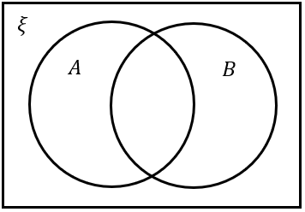 | - $B$ | - $A∩B$
- $A∪B$ | - $\overline{A}$ | - $\overline{B}$
- $\overline{A}∩\overline{B}$ | - $\overline{A}∩B$ | - $A∩\overline{B}$
- $\overline{\left(A∪B\right)}$ | - $ξ$ | - $\left(A∪B\right)-\left(A∩B\right)$

- Venn Diagrams and Sets
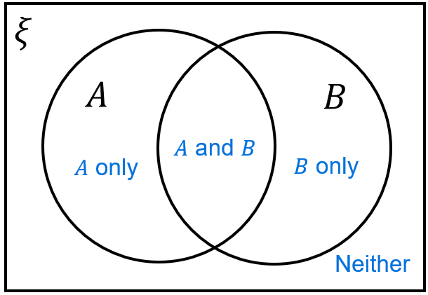

- Addition Rule for Sets
Imagine you’re counting students who study maths or science.
If you add the students who study maths and students who study science,
you will double-count students who study both.
So, you must subtract the people who study both.
$\left|A∪B\right| = \left|A\right|+\left|B\right|-\left|A∩B\right|$
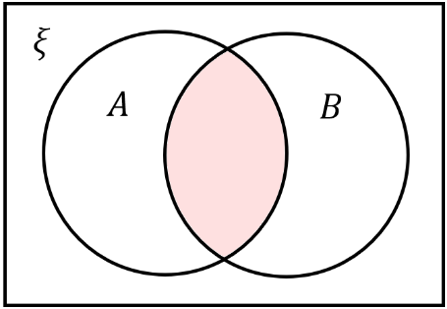
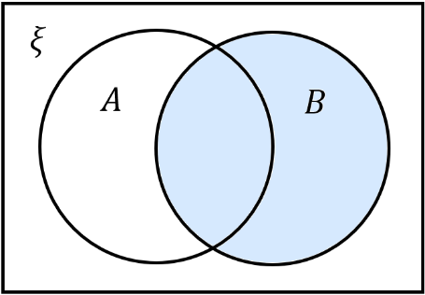
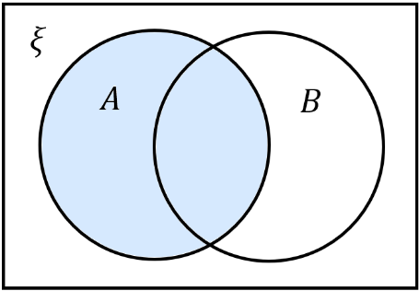
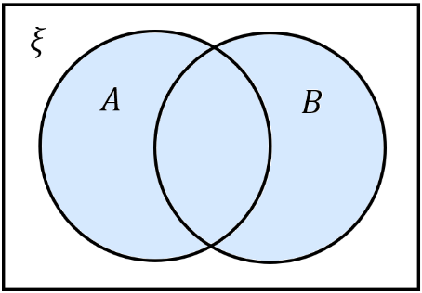

$=$ $+$ $-$

- Example Apply addition rule for sets.
In a sports club, 22 play basketball, 18 play volleyball, and 8 play both sports. How many members play basketball or volleyball?  $$\left|V∪B\right|=\left|V\right|+\left|B\right|-\left|V∩B\right| \\ =22+18-8 \\ =32$$ | A survey of 80 teenagers found that 35 like pop music, 28 like rock music, and 12 like both genres. How many teenagers like pop or rock music?  $$\left|P∪R\right|=\left|P\right|+\left|R\right|-\left|P∩R\right| \\ =28+12-12 \\ =51$$

- Practice
In a school of 120 students, 45 study Spanish, 52 study French, and 15 study both languages. How many students study Spanish or French?  82 | $$A=\left\{whole numbers from 1 to 10 inclusive\right\}$$  $$B=\left\{even numbers from 1 to 15\right\}$$  Find $\left|A∪B\right|$ without listing the set.  12

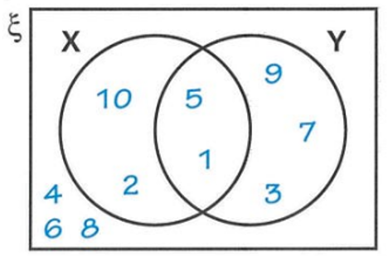
Foundation

- List the elements of set X.  $$X = \{10, 5, 2, 1\}$$ | - List the elements of set Y.  $$Y = \{9, 5, 1, 7, 3\}$$
- List the elements of both set X and set Y.  $$X ∩ Y = \{5, 1\}$$ | - List the elements of set X or set Y.  $$X∪Y=\left\{10, 5, 2, 1,9, 7, 3\right\}$$
- List the elements that are not in set X.  $$\overline{X}=\left\{4, 6, 8, 9, 7, 3\right\}$$ | - List the elements that are not in set Y.  $$\overline{Y}=\left\{10, 2, 4, 6, 8\right\}$$

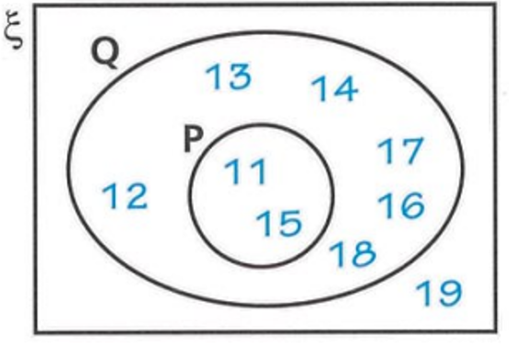

- List the elements of set P.  $$P=\left\{11, 5\right\}$$ | - Sven says that 11 is not an element of set Q. Is Sven correct?  Sven is incorrect. 11 is an element of Q
- Write down the elements of set Q.  $$Q=\left\{12, 13, 14, 17, 16, 18, 11, 15\right\}$$ | - How many elements are not in set Q?  $$1$$
- How many elements are not in set P?  $$7$$ | - Explain why the set “both P and Q” are the same as those of set P.  P ⊆ Q (P is subset of Q)

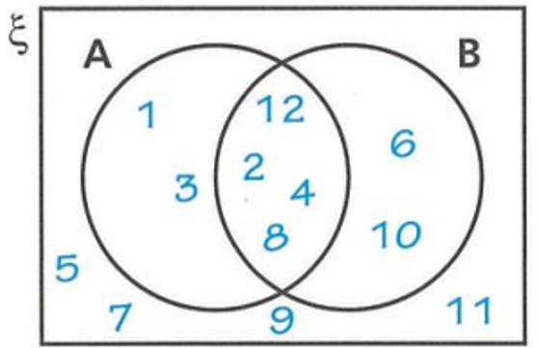

- List the elements of A ∩ B.  $$A∩B=\left\{12, 2, 4, 8\right\}$$ | - List the elements of A ∪ B.  $$A∪B=\left\{1, 3, 2, 12, 4, 8, 6, 10\right\}$$
- List the elements of A'.  $$A^{'}=\left\{5, 7, 9, 6, 10 ,11\right\}$$ | - List the elements of B'.  $$B^{'}=\left\{1, 3, 5, 7, 9, 11\right\}$$

- Shade the region:
A ∩ B A ∪ B
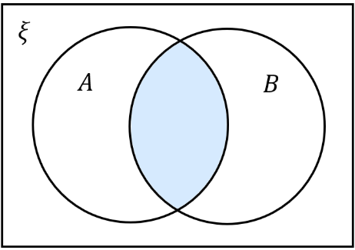
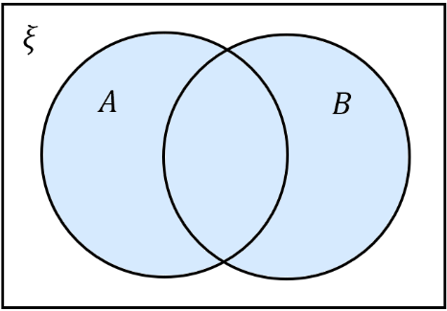
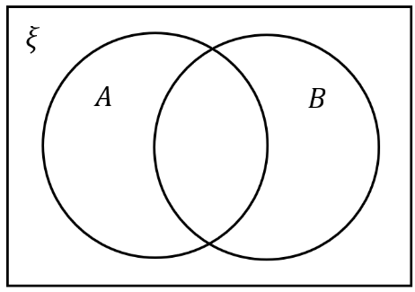
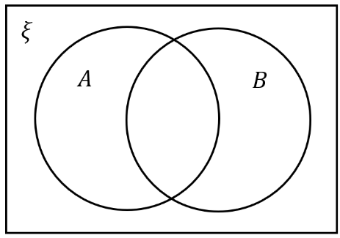

- On each diagram, shade the region A'.
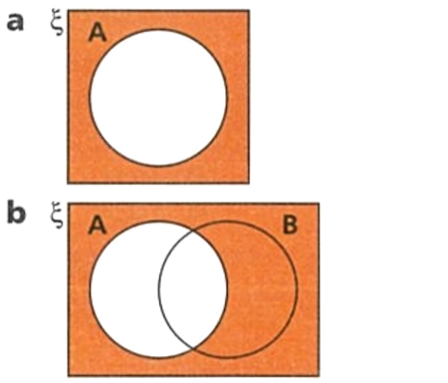
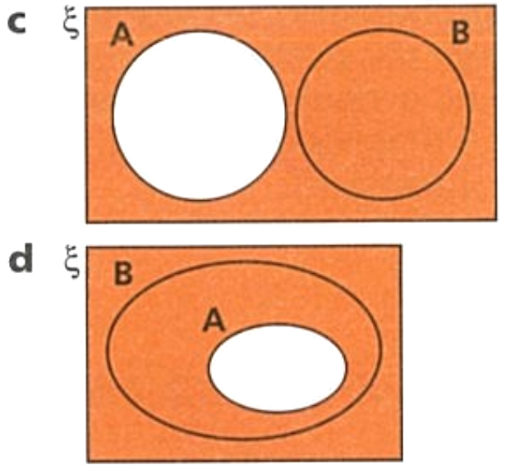
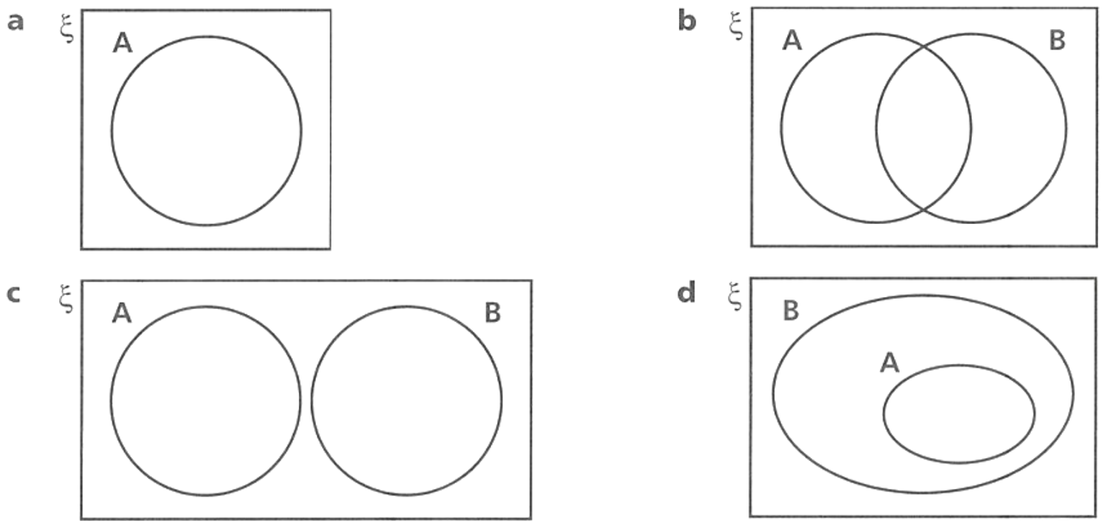

- The two Venn diagrams show A and $B'$.
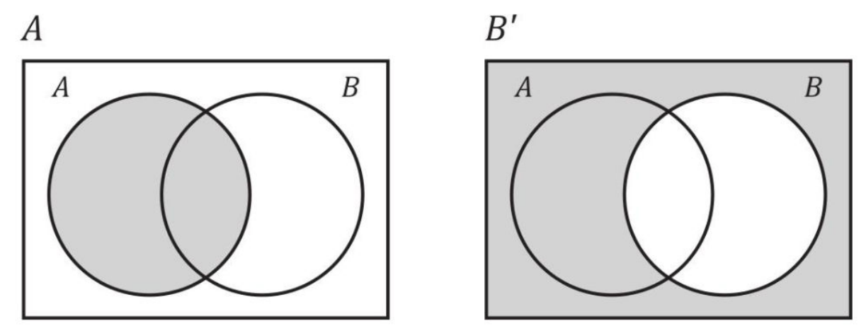

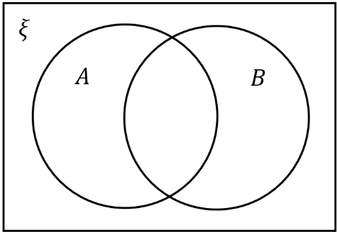  - Shade $A∪B'$ by shading everything that is either in the first picture or in the second picture. | 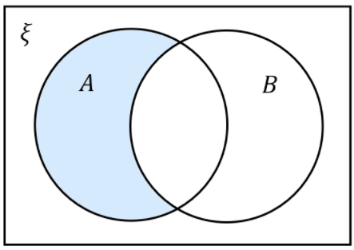  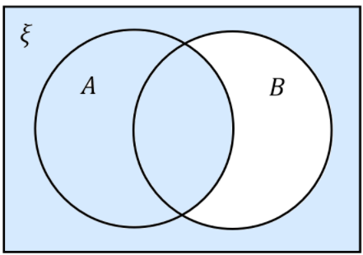  - Shade $A∩B'$ by shading anything that is in both the first and second picture

- The two Venn diagrams show $A’$ and B.
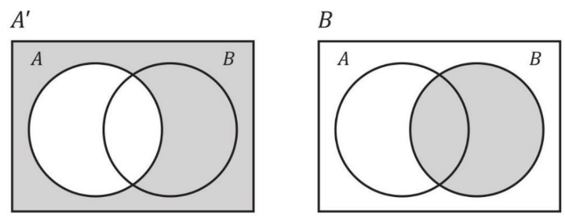

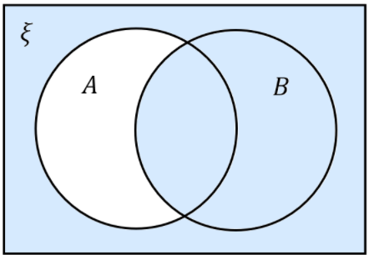  - Shade $A'∪B$ | 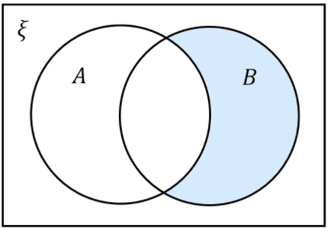  - Shade $A'∩B$

Development
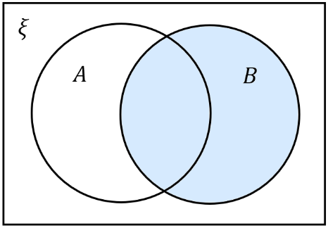
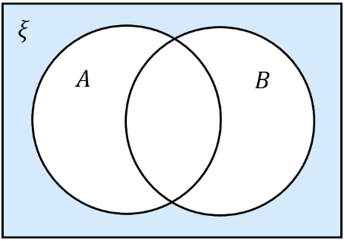
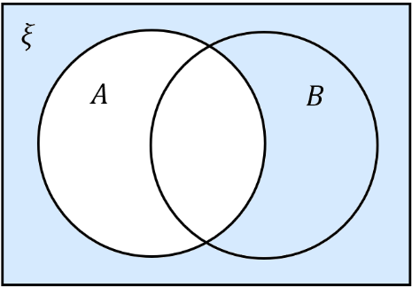
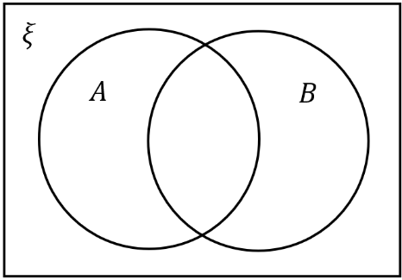
- Shade the Venn diagrams with the set.
- $A$  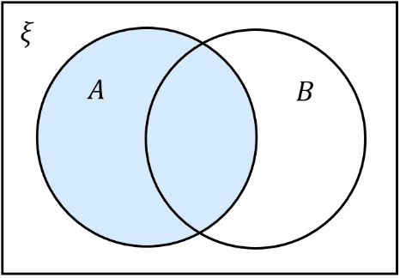 | - $B$ | - $A∩B$ | - $A∪B$
- $A∩\overline{B}$  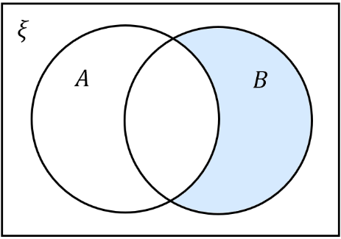  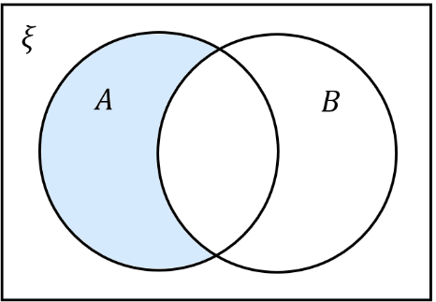 | - $\overline{A}∩B$ | - $\overline{A}$ | - $\overline{A}∩\overline{B}$

- Here are two sets, A and B.
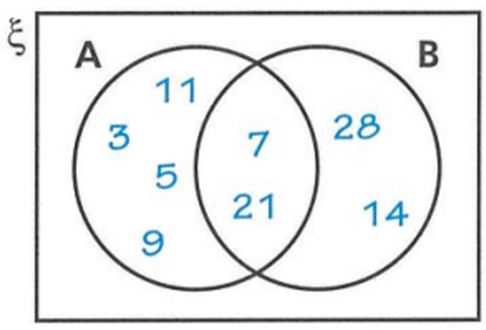
  - Write the elements of $A∪B$
$$A∪B=\left\{3, 11, 5, 9 , 7, 21, 28, 14\right\}$$
  - Write the elements of $A∩B$
$$A∩B=\left\{7, 21\right\}$$
  - Write down the elements of $\overline{A}∩B$.
$$\overline{A}∩B=\left\{28, 14\right\}$$
  - Write down the elements of $A∩\overline{B}$.
$$A∩\overline{B}=\left\{11, 3, 5, 9\right\}$$
- ξ = {1, 2, 3, 4, 5, 6, 7, 8} A = {1, 2, 3, 4, 5} B = {2, 3, 4}
Which of the Venn diagrams would you use to represent these sets?
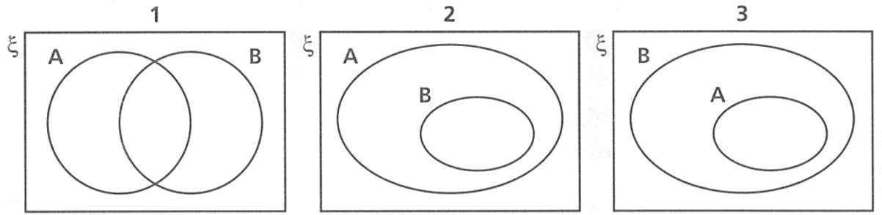

Venn diagram 2, B is a subset of A
- Here are two sets represented on a Venn diagram.
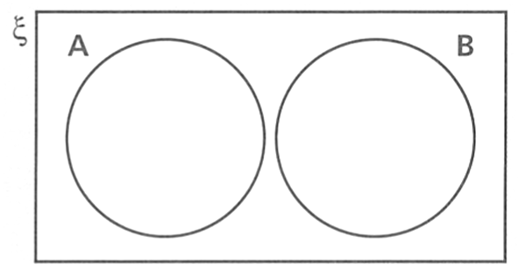
  - Explain why A ∩ B does not contain any elements.
The two sets are disjoint (mutually exclusive)
There are no elements common to A and B
  - Give an example of two possible sets A and B.
Even numbers, odd numbers

- Here are two sets represented on a Venn diagram.
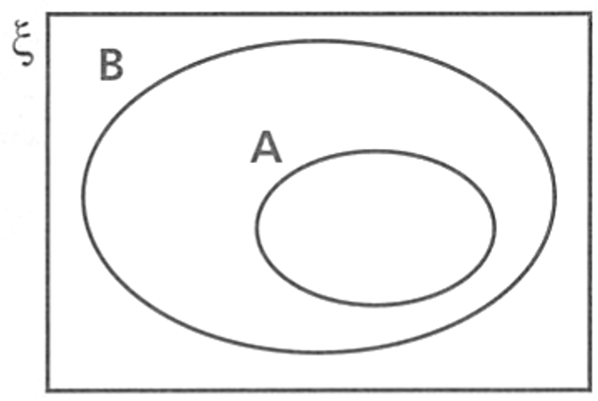
  - Explain why A ∩ B is equal to the elements of set A.
A is a subset of B
So every element of A is in B
  - Give an example of two possible sets A and B.
B: even numbers, A: multiples of 4
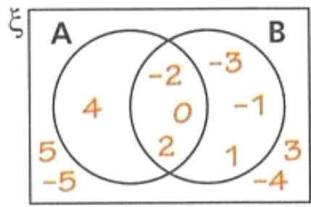
- ξ = {numbers from -5 to 5 inclusive}
A = {-2, 0, 2, 4} B = {-3, -2, -1, 0, 1, 2}
Draw a Venn diagram to represent this information.

- ξ = {integers between 1 and 20 inclusive}
List the elements of these sets.
  - A = {odd numbers}
  - B = {multiples of 2}
  - Draw a Venn diagram to represent the information.
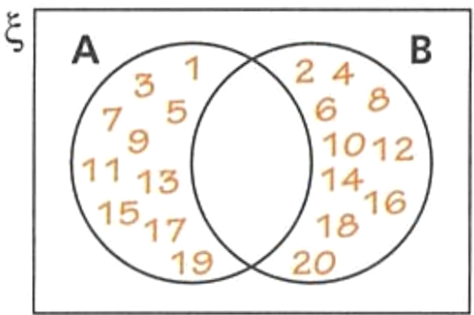
  - Why are there no elements in both set A and set B?
$$A = \left\{1, 3, 5, 7, 9, 11, 13, 15, 17, 19\right\}$$
B = {2, 4, 6, 8, 10, 12, 14, 16, 18, 20}
No number is both odd and even

- In a class of 30 students, 18 play soccer, 12 play basketball, and 7 play both sports.
How many students play soccer or basketball?

18 + 12 – 7 = 23

- In a group of 150 employees, 65 have a car, 85 have a smartphone, and 40 have both.
How many employees have a car or a smartphone?

65 + 85 – 40 = 110

- A gym has 150 members. 90 use the weights, 110 use cardio equipment.
If all members use at least one type of equipment, how many use both?

150 = 90 + 110 – $x$
$$x=50$$
- 40 children take part in a school show. All the children either sing, dance or do both.
35 children dance. 28 children sing.
How many children sing and dance?
Using addition rule, $40=35+28-x$
$$x=23$$

Mastery
- Select the Venn diagram that best shows the relationship between each pair of sets A and B:
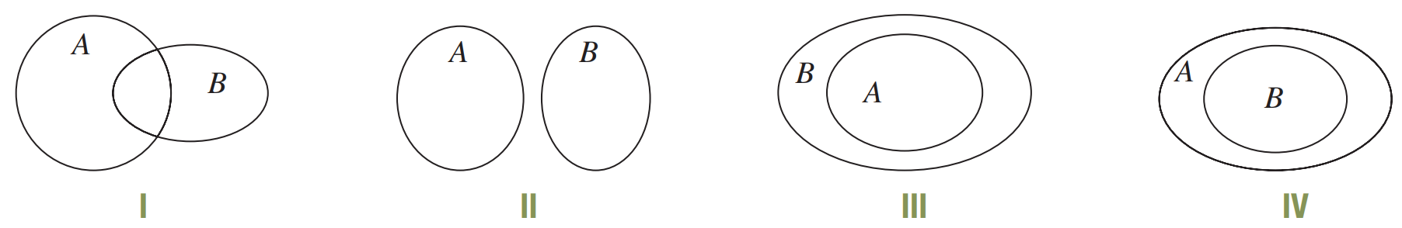

  - A = {Tasmania}, B = {states of Australia}
III
  - A = {7, 1, 4, 8, 3, 5}, B = {2, 9, 0, 7}
I
  - A = {l, e, a, r, n}, B = {s, t, u, d, y}
II
  - A = {politicians in Australia}, B = {politicians in NSW}.
IV

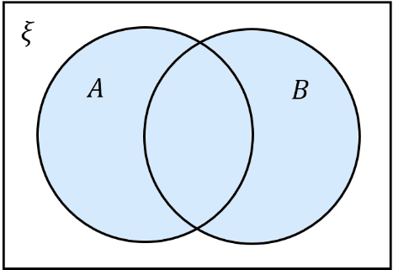  - Shade $A∪B$  Hence shade $\overline{A∪B}$ | - Shade $\overline{A}$  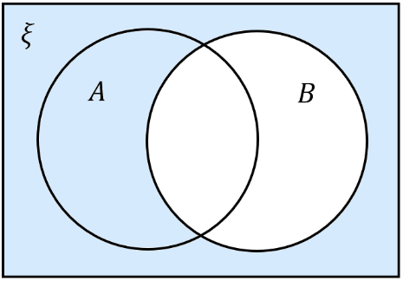  Shade $\overline{B}$  Shade $\overline{A}∩\overline{B}$
- Hence what can you conclude about $\overline{A∪B}$ and $\overline{A}∪\overline{B}$?

They are the same

- Identify the following regions:
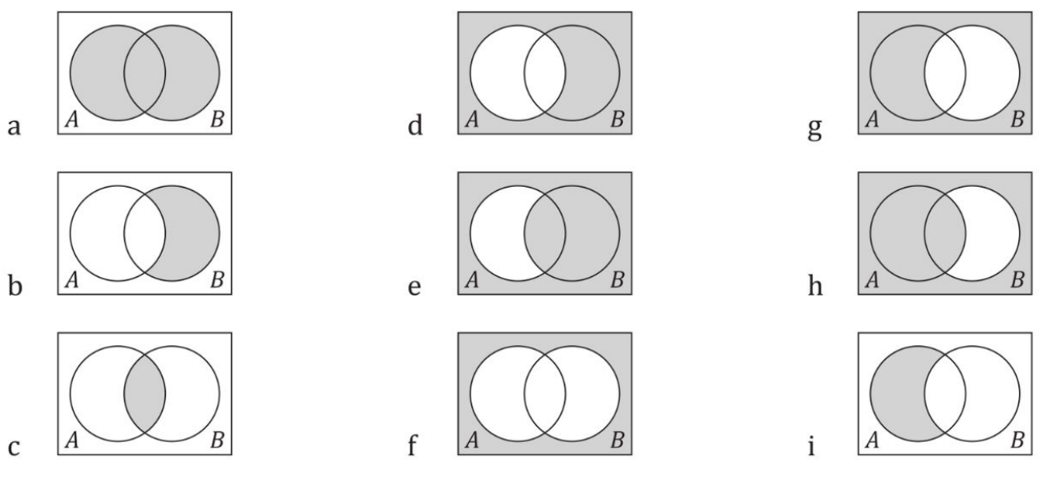  $$A∪B$$ | $$A'$$ | $$B'$$
$$\overline{A}∩B$$ | $$\overline{A}∪B$$ | $$A∪\overline{B}$$
$$A∩B$$ | $$\overline{A∪B} or \overline{A}∪\overline{B}$$ | $$A∩\overline{B}$$

- Here are three sets X, Y and Z. Write down the elements of
  - X ∩ Y
{D, G}
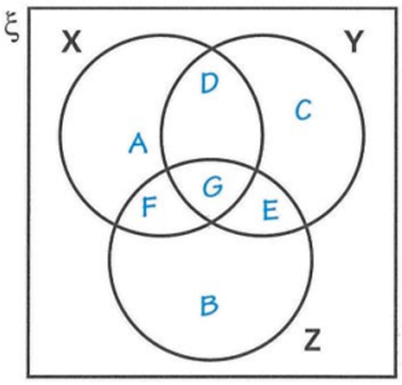
  - Y ∩ Z
{G, E}
  - (X ∩ Y) ∩ Z
G
  - Y'
A, F, B
  - X' ∪ Y'
{C, E, B, A, F}
  - X ∪ Y'
{A, D, G, F, B}
  - (X ∪ Y)'
{B}
  - (X ∪ Y) ∩ Z'
{A, D, C}

- Shade the region $\left(A∩B\right)∪C$  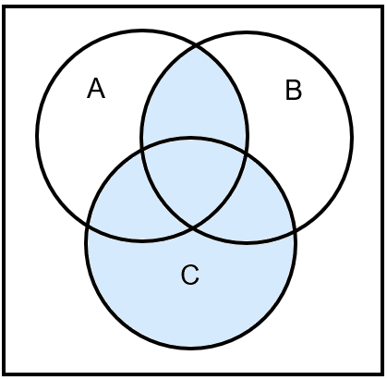  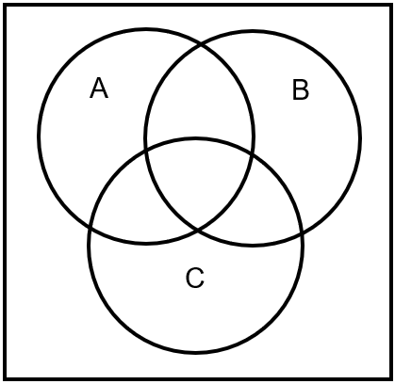 | 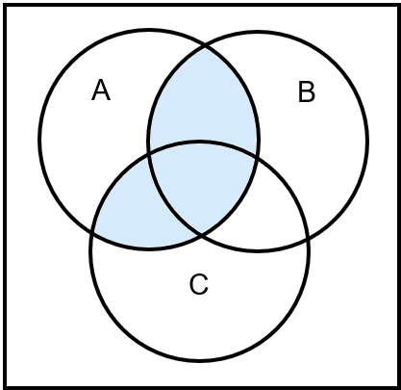  - Shade the region $A∩\left(B∪C\right)$

Compound Events, Venn Diagrams, Set Notation

- Compound Events using Venn Diagrams and Set Notation
$$P\left(A∪B\right)$$  Probability of either A or B.  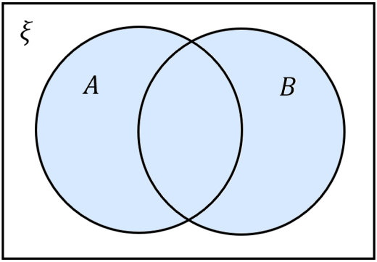 | $$P\left(A∩B\right)$$  Probability of both A and B.
$$P\left(A∩\overline{B}\right)$$  Probability of A only.  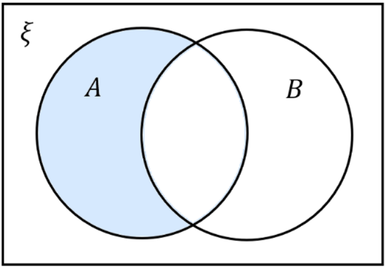 | $$P\left(\overline{A}∩B\right)$$  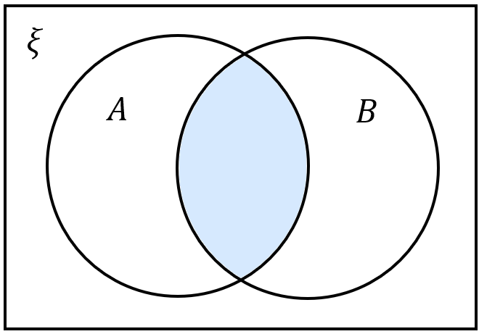  Probability of B only.  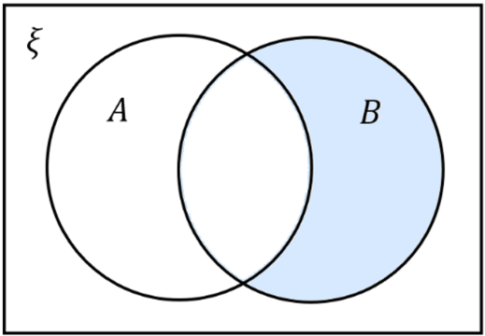  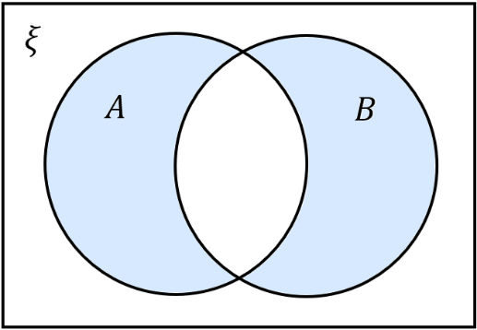
$$P\left(\overline{A}∩\overline{B}\right)=1-P\left(A∪B\right)$$  Probability of neither A nor B.  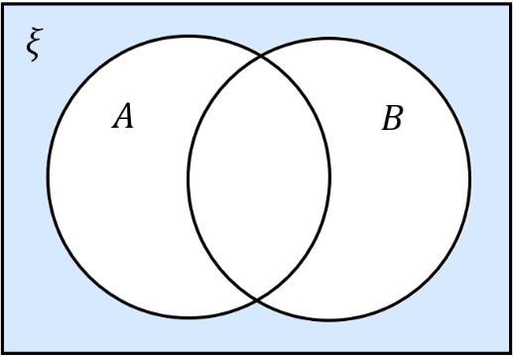 | $$P\left(A∪B\right)-P\left(A∩B\right)$$  Probability of A or B but not both.

- Addition Rule of Probability
$$P\left(A∪B\right)=P\left(A\right)+P\left(B\right)-P(A∩B)$$

$=$ $+$ $-$

For two events that are mutually exclusive, $P\left(A∩B\right)=0$, so:
$$P\left(A∪B\right)=P\left(A\right)+P\left(B\right)$$
$ξ$
$A$
$B$

Always draw a Venn diagram to visualise the scenario rather than relying on the formulas.

- Example Applying the addition rule to probability.
One card is selected at random from a pack of 100 cards numbered from 1 to 100.  Let $A=\left\{even cards\right\}$  Let $B=\left\{cards less than 20\right\}$  Find $P\left(A∪B\right)$  $ξ$  $$B$$  $A$  $$P\left(A∪B\right)=P\left(A\right)+P\left(B\right)-P\left(A∩B\right) \\ =\frac{50}{100}+\frac{19}{100}-\frac{9}{100} \\ =\frac{3}{5}$$ | In a class of 30 girls, 13 play tennis and 23 play netball. 7 girls play both sports.  Let $T=\left\{students who do tennis\right\}$  Let $N=\left\{students who do netball\right\}$  Find $P\left(\overline{T}∩\overline{N}\right)$  $ξ$  $$N$$  $T$  $$P\left(T∪N\right)=P\left(T\right)+P\left(N\right)-P\left(T∩N\right) \\ =\frac{13}{30}+\frac{23}{30}-\frac{7}{30} \\ =\frac{29}{30} \\ P\left(\overline{T}∩\overline{N}\right)=1-P\left(T∪N\right) \\ =\frac{1}{30}$$

- Practice
A survey of 40 Year 9 students found that 18 students study French and 25 students study Drama. 8 students study both French and Drama.  Let $F=\left\{students who study French\right\}$  Let $D=\left\{student who study drama\right\}$  Find $P\left(F∩D\right)$  $ξ$  $$D$$  $F$  $$\frac{1}{5}$$ | In a library of 200 books, 85 books are fiction and 60 books were published recently. 30 books are both fiction and recent.  Let $F=\left\{Fiction books\right\}$  Let $R=\left\{Recent books\right\}$  Find $P\left(F∩\overline{R}\right)$  $ξ$  $$R$$  $F$  $$\frac{11}{40}$$

Foundation
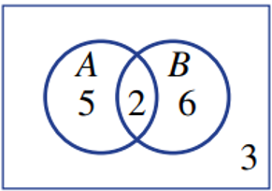
- The Venn diagram shows the distribution of elements in two sets, A and B.

  - Find:
- $n\left(A∩B\right)$  2 | - $n\left(A^{'}∩B\right)$  6 | - $n\left(A∩B^{'}\right)$  5 | - $n\left(A^{'}∩B^{'}\right)$  3
- $n\left(A\right)$  7 | - $n\left(B^{'}\right)$  8 | - $n\left(A∪B\right)$  13 | - $n\left(ξ\right)$  16

  - Find:
- $P\left(A∩B\right)$  $$\frac{1}{8}$$ | - $P\left(A^{'}\right)$  $$\frac{9}{16}$$ | - $P\left(A∩B^{'}\right)$  $$\frac{5}{16}$$

- From a total of 10 people, 5 like apples, 6 like bananas, and 4 like both.
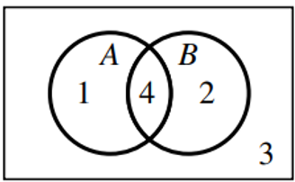
Draw a Venn diagram and find:
- $n\left(A^{'}∩B\right)$  $$2$$ | - $n\left(A^{'}∩B^{'}\right)$  $$3$$
- $P\left(A∩B\right)$  $$\frac{2}{5}$$ | - $P\left(A∪B\right)$  $$\frac{7}{10}$$

- A die is thrown. Let $A$ be the event that an even number appears.
Let $B$ be the event that a number greater than 2 appears.
  - Are A and B mutually exclusive?
No, since $A∩B=\left\{4,6\right\}≠∅$
  - Find:
- $P\left(A\right)$  $$P\left(A\right)=\frac{3}{6}=\frac{1}{2}$$ | - $P\left(B\right)$  $$P\left(B\right)=\frac{4}{6}=\frac{2}{3}$$ | - $P\left(A∩B\right)$  $$P\left(A ∩ B\right)=\frac{2}{6}=\frac{1}{3}$$ | - $P\left(A∪B\right)$  $$P\left(A\right)+ P\left(B\right)- P\left(A ∩ B\right)$$  $$=\frac{1}{2}+\frac{2}{3}-\frac{1}{3}=\frac{5}{6}$$

- A number is chosen from the set of positive integers between 1 and 20 inclusive.
A is the set of multiples of 3 less than 20, and B is the set of factors of 15.
Find the probabilities:
- $P(A∩B)$  A ∩ B = {3, 15}  $$\frac{2}{20}=\frac{1}{10}$$ | - $P(A∪B)$  A ∪ B = {1, 3, 5, 6, 9, 12, 15, 18}  $$\frac{8}{20}=\frac{2}{5}$$ | - $P(\overline{A})$  Ā = {1, 2, 4, 5, 7, 8, 10, 11, 13, 14, 16, 17, 19, 20}  $$\frac{14}{20}=\frac{7}{10}$$ | - $P(A∩\overline{B})$  A ∩ B̄ = {6, 9, 12, 18}  $$\frac{4}{20}=\frac{1}{5}$$

Development
- A card is selected from a standard deck of 52 playing cards (4 suits, no jokers).
Let A be the event 'the card is a diamond' and B be the event 'the card is a jack'.
  - Find:
- $P\left(A\right)$  $$\frac{13}{52}=\frac{1}{4}$$ | - $P\left(A^{'}\right)$  $$1-\frac{1}{4}=\frac{3}{4}$$ | - $P\left(A∩B\right)$  $$\frac{1}{52}$$

  - Use the addition rule to find $P\left(A∪B\right)$.
$$P\left(A∪B\right)=P\left(A\right)+ P\left(B\right)- P\left(A ∩ B\right)$$
$$\frac{13}{52}+\frac{4}{52}-\frac{1}{52}=\frac{4}{13}$$
  - Find the probability that the card is a jack or not a diamond.

$$P\left(B∪A^{'}\right)=P\left(B\right)+P\left(A^{'}\right)-P\left(B∩A^{'}\right)$$
$$=\frac{4}{52}+\frac{39}{52}-\frac{3}{52}=\frac{10}{13}$$

- $P\left(A\right)=$ $\frac{1}{2}$ $P\left(B\right)=$ $\frac{1}{3}$  Find:  - $P\left(\overline{A}\right)$  $$\frac{1}{2}$$  - $P\left(\overline{B}\right)$  $$\frac{2}{3}$$  - $P\left(A∩B\right)$  $$\frac{1}{3}$$  - $P\left(A∪B\right)$  $$\frac{1}{2}$$  - $P(\overline{A∪B})$  $$\frac{1}{2}$$ | - $P\left(A\right)=$ $\frac{2}{5}$ $P\left(B\right)=$ $\frac{1}{5}$  Find:  - $P\left(\overline{A}\right)$  $$\frac{3}{5}$$  - $P\left(\overline{B}\right)$  $$\frac{4}{5}$$  - $P\left(A∩B\right)$  $$\frac{3}{5}$$  - $P\left(A∪B\right)$  $$0$$  - $P(\overline{A∪B})$  $$1$$ | - $P\left(A\right)=$ $\frac{1}{2}$ $P\left(B\right)=$ $\frac{1}{3}$  $P\left(A∩B\right)=$ $\frac{1}{6}$  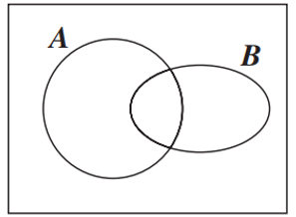  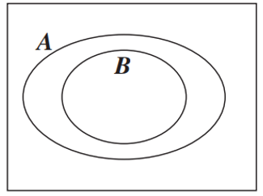  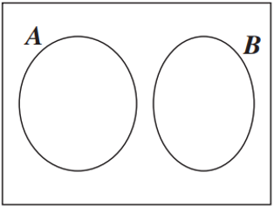  Find:  - $P\left(\overline{A}\right)$  $$\frac{1}{2}$$  - $P\left(\overline{B}\right)$  $$\frac{2}{3}$$  - $P\left(A∪B\right)$  $$\frac{2}{3}$$  - $P(\overline{A∪B})$  $$\frac{1}{3}$$  - $P(\overline{A∩B})$  $$\frac{5}{6}$$

Mastery
- Use the addition rule P(A ∪ B) = P(A) + P(B) - P(A ∩ B) to answer the following questions.
Drawing a Venn diagram helps.
  - If P(A) = $\frac{1}{5}$, P(B) = $\frac{1}{3}$ and P(A ∩ B) = $\frac{1}{15}$, find P(A ∪ B).

$$P\left(A ∪ B\right)= P\left(A\right)+ P\left(B\right)- P\left(A ∩ B\right)$$
$$=\frac{1}{5}+\frac{1}{3}-\frac{1}{15}=\frac{7}{15}$$
  - If P(A) = $\frac{1}{2}$, P(B) = $\frac{1}{3}$ and P(A ∪ B) = $\frac{5}{6}$, find P(A ∩ B).

$$P\left(A ∩ B\right)= P\left(A\right)+ P\left(B\right)- P\left(A ∪ B\right)$$
$$=\frac{1}{2}+\frac{1}{3}-\frac{5}{6}= 0$$
  - If P(A ∪ B) = $\frac{9}{10}$, (A ∩ B) = $\frac{1}{5}$ and P(A) = $\frac{1}{2}$, find P(B).

$$P\left(B\right)= P\left(A ∪ B\right)- P\left(A\right)+ P\left(A ∩ B\right)=\frac{9}{10}-\frac{1}{2}+\frac{1}{5}$$
$$=\frac{3}{5}$$
  - If A and B are mutually exclusive and P(A) = $\frac{1}{7}$ and P(B) = $\frac{4}{7}$, find P(A ∪ B).

If A and B are mutually exclusive, P(A ∩ B) = 0
$$P\left(A ∪ B\right)= P\left(A\right)+ P\left(B\right)- P\left(A ∩ B\right)=\frac{1}{7}+\frac{4}{7}- 0 =\frac{5}{7}$$

  - Find P(A ∩ B') when P(A ∪ B) = 0.8, P(A) = 0.5 and P(B) = 0.4

$$P(A ∪ B) = P(A) + P(B) - P(A ∩ B)$$
$$0.8 = 0.5 + 0.4 - P(A ∩ B)$$
$$P(A ∩ B) = 0.1$$
$$P\left(A ∩ B^{'}\right) = P(A) - P(A ∩ B) = 0.5 - 0.1 = 0.4$$
  - Find P ( A ′ ∩ B) when P (A ∪ B) = 0.76, P (A) = 0.31 and P (B) = 0.59

$$P(A ∪ B) = P(A) + P(B) - P(A ∩ B)$$
$$0.76 = 0.31 + 0.59 - P(A ∩ B)$$
$$P(A ∩ B) = 0.14$$
$$P(A'∩ B) = P(B) - P(A ∩ B) = 0.59 - 0.14 = 0.45$$

- 2012 VCE Band 4
A car manufacturer is reviewing the performance of its car model $X$.
It is known that at any given six-month service, the probability of model X requiring an oil change is $\frac{17}{20}$, the probability of model $X$ requiring an air filter change is $\frac{3}{20}$, and the probability of model $X$ requiring both is $\frac{1}{20}$.
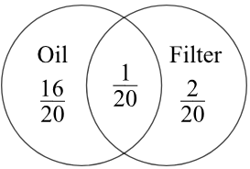
  - State the probability that at any given six-month service model $X$ will require an air filter change without an oil change.

$$P\left(A without O\right)= P\left(A ∩ O^{'}\right)= P\left(A\right)- P\left(A ∩ O\right)=\frac{3}{20}-\frac{1}{20}=\frac{2}{20}=\frac{1}{10}$$
  - The car manufacturer is developing a new model. The production goals are that the probability of model $Y$ requiring an oil change at any given six-month service will be $\frac{m}{m+n}$, the probability of model $Y$ requiring an air filter change will be $\frac{n}{m+n}$
and the probability of model $Y$ requiring both will be $\frac{1}{m+n}$, where m, n ∈ Z⁺.
Determine $m$ in terms of $n$ if the probability of model $Y$ requiring an air filter change without an oil change at any given six-month service is 0.05.
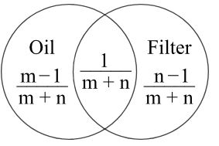
$$P\left(A without O\right)= P\left(A\right)- P\left(A ∩ O\right)=\frac{n}{m+n}-\frac{1}{m+n}=\frac{n-1}{m+n}$$
$$\frac{n-1}{m+n}=\frac{1}{20}$$
$$20\left(n-1\right)= m+n$$
$$20n - 20 = m + n$$
$$19n - 20 = m$$
$$∴ m = 19n - 20$$
- 2011 VCE Band 5
Two events, A and B, are such that P(A) = 3/5 and P(B) = 1/4.
If A' denotes the complement of A, calculate P(A' ∩ B) when:
  - P(A ∪ B) = $\frac{3}{4}$
  - A and B are mutually exclusive.
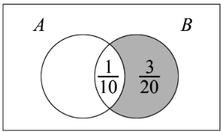
$a) Using P(A ∪ B) = P(A) + P(B) - P(A ∩ B)$
$$\frac{3}{4}=\frac{3}{5}+\frac{1}{4}- P\left(A ∩ B\right)$$
$$P\left(A ∩ B\right)=\frac{1}{10}$$
$$P\left(A^{'}∩ B\right)= P\left(B\right)- P\left(A ∩ B\right)=\frac{1}{4}-\frac{1}{10}=\frac{3}{20}$$
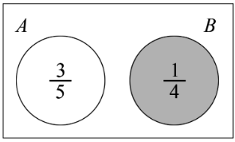
$$b) P\left(A^{'}∩B\right)=P\left(B\right)=\frac{1}{4}$$

Conditional Probability

- Conditional Probability
Conditional probability measures how likely one event will occur when we already know another event has happened.
Conditional probability only applies when two events are
- dependent (for multistage experiments)
- not mutually exclusive (for compound events).
Key phrases that signal conditional probability:
"If... then" - "If it's raining, then what's the probability of carrying an umbrella?"
"Given" - "Given that a student studies, what's the probability they pass?"
"Knowing that" - "Knowing that someone is tall, what's the probability they play basketball?"

- Investigation Conditional probability.
Compound events scenario:
Jenny will win a game if she rolls an odd number on a die.
The sample space is the possible numbers.: $S=\left\{1, 2, 3, 4, 5, 6\right\}$
The event space is the odd numbers: $A=\{1, 3, 5\}$
As she rolls the die, she closes her eyes. Someone shouts out “It’s a prime number!”
Prime numbers are odd numbers are n……-m……………… e…………………
From this information, we can write:
The reduced sample space is prime numbers: $B=\{$ ……, ……, …… }
The reduced event space is prime odd numbers: $A∩B=\{$ ……, …… $\}$

For her, what is the probability of winning?
$$P\left(Jenny wins, given that the number is prime\right)=\frac{|reduced event space|}{|reduced sample space|}$$
$$=\frac{ }{ }$$

Illustrate this on the Venn diagram.
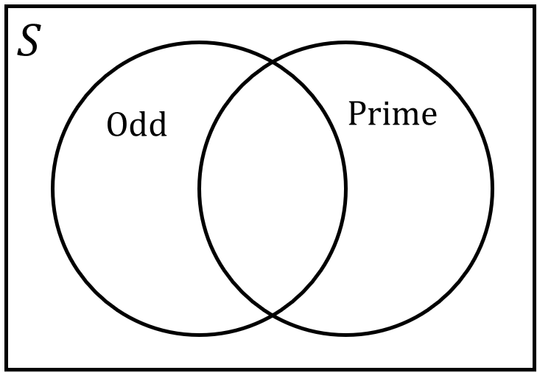

- Conditional Probability Formula
The probability of A, given B:
The sample space is reduced to $B$ and the event space is reduced to $A∩B$
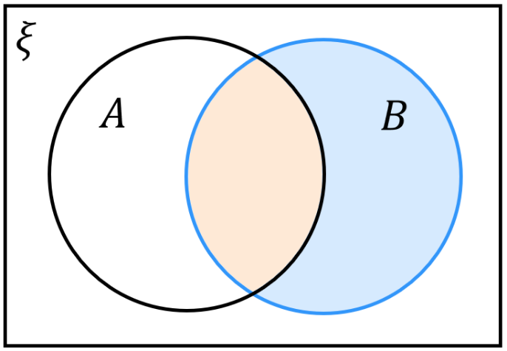
$$P\left(A | B\right)=\frac{|A∩B|}{\left|B\right|}=\frac{P\left(A∩B\right)}{P\left(B\right)}$$

- $P\left(A | B\right)≠P\left(B | A\right)$ unless $P\left(A\right)=P\left(B\right)$

- Example Apply conditional probability formula (compound events).
In a population, 35% of people have blond hair, 15% green eyes, and 10% have both.
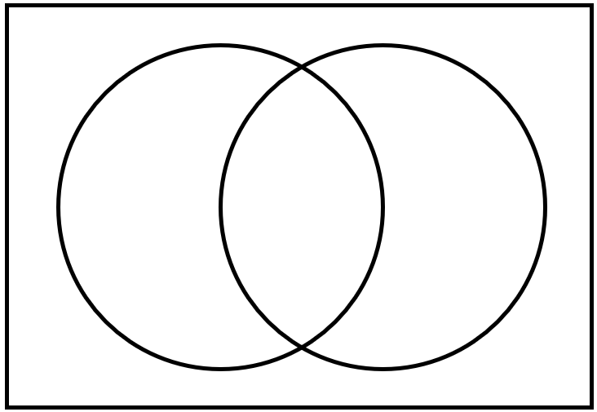
A person is chosen from this population at random.

- Find the probability they have green eyes, given they have blond hair.  $$P\left(G | B\right)=\frac{P\left(G∩B\right)}{P\left(B\right)} \\ =\frac{0.1}{0.35} \\ =\frac{2}{7}$$ | - Find the probability that have blond hair, given they have green eyes.  $$P\left(B | G\right)=\frac{P\left(B∩G\right)}{P\left(G\right)} \\ =\frac{0.1}{0.15} \\ =\frac{2}{3}$$

- Practice
Lara is an athlete who enters a swimming and running race.  She has a 44% chance of winning the swimming race and a 37% chance of winning both. Find the probability that she wins the running race if she has won the swimming race.  $$84\%$$ | All 30 students in a class study either history or geography. If 18 do only geography and  8 do both subjects, find the probability that a student does geography, given that the  student does history.  $$\frac{8}{12}=\frac{2}{3}$$
- Conditional Probability for Multistage Events
The conditional probability formula also applies to multistage events.
Stage 1 | Stage 2 | Events
$$P\left(A\right)$$  $A$  $$P\left(\overline{A}\right)$$  $\overline{A}$ | $$P\left(B | A\right)$$  $B$  $$P\left(\overline{B} | A\right)$$  $\overline{B}$  $$P\left(B | \overline{A}\right)$$  $B$  $$P\left(\overline{B} | \overline{A}\right)$$  $\overline{B}$ | $$P\left(A∩B\right)$$  $$P\left(A∩\overline{B}\right)$$  $$P\left(\overline{A}∩B\right)$$  $$P\left(\overline{A}∩\overline{B}\right)$$
- For $P\left(B | A\right)$, $A$ is the first event.
- Remember that for multistage events, order matters:
- $P\left(A∩B\right)≠P\left(B∩A\right)$
- $P\left(A | B\right)≠P\left(B | A\right)$

- Interpret conditional probability scenario.
For each scenario, identify the first event, and the probabilities that are given.
Then find the missing probabilities by filling in the tree diagram.
- A weather forecast shows there's a 35% chance of rain tomorrow.
When it rains, Sarah takes the bus 90% of the time.
When it doesn't rain, she takes the bus only 25% of the time.
$R$  $\overline{R}$ | $B$  $\overline{B}$  $B$  $\overline{B}$ | $$P\left(R∩B\right)=$$  $$P\left(R∩\overline{B}\right)=$$  $$P\left(\overline{R}∩B\right)=$$  $$P\left(\overline{R}∩\overline{B}\right)=$$ | $P\left(Bus\right)=$

- In a school, 60% of students study regularly.
Among students who study regularly, 15% still fail their exams.
Among students who don't study regularly, 40% will pass their exams.
$P\left(Pass\right)=$

- Conditional Probability for Multistage Events
1. Read scenario and identify the probabilities given.
Carefully determine which is the first event.
2. Set up tree diagram with given probabilities.
3. Find missing probabilities.
4. Use formula $P\left(A | B\right)=$ $\frac{P\left(A∩B\right)}{P\left(B\right)}$ to answer question.

- Example Apply conditional probability formula (multistage events)
The probability of the zoo having an animal born on a day is 40%.
The zoo publishes an article 80% of the time when there is a birth of a baby animal.
When there is no birth, there is a 30% probability the zoo will publish an article.
Find the probability that a baby animal was born given that an article was published.
1. $40\%=P\left(B\right)$ $80\%=P\left(A | B\right)$ $30\%=P\left(A | \overline{B}\right)$
2.
Baby | Article | Events
$$P\left(B\right)=0.4$$  $B$  $$P\left(A | \overline{B}\right)=0.3$$  $\overline{B}$ | $$P\left(A | B\right)=0.8$$  $A$  $\overline{A}$  $A$  $\overline{A}$ | $$P\left(B∩A\right)=$$  $$P\left(B∩\overline{A}\right)=$$  $$P\left(\overline{B}∩A\right)=$$  $$P\left(\overline{B}∩\overline{A}\right)=$$
3.
$$0.7$$
Baby | Article | Events
$$P\left(B\right)=0.4$$  $B$  $$0.2$$  $$P\left(A | \overline{B}\right)=0.3$$  $$0.6$$  $\overline{B}$ | $$P\left(A | B\right)=0.8$$  $A$  $\overline{A}$  $A$  $\overline{A}$ | $$P\left(B∩A\right)=0.32$$  $$P\left(B∩\overline{A}\right)=0.08$$  $$P\left(\overline{B}∩A\right)=0.18$$  $$P\left(\overline{B}∩\overline{A}\right)=0.42$$
4.
$$P\left(B | A\right)=\frac{P\left(B∩A\right)}{P\left(A\right)}=\frac{P\left(B∩A\right)}{P\left(B∩A\right)+P\left(\overline{B}∩A\right)} \\ =\frac{0.32}{0.32+0.18}=0.64$$
- Practice
The probability that a patient arriving at the hospital has a serious condition is 25%.
When a patient has a serious condition, the hospital orders additional tests 90% of the time.
When a patient does not have a serious condition, the hospital still orders additional tests 15% of the time.
Find the probability that a patient has a serious condition given that additional tests were ordered.

$$\frac{2}{3}$$
A factory produces items where 12% are defective.
Non-defective items pass the quality check 92% of the time.
Defective items fail the quality check 85% of the time.
Find the probability that an item is defective given that it failed the quality check.

$$≈59.2\%$$

- Identify conditional probability for independent and mutually exclusive events.
Multistage independent events
- Two coins are flipped one after the other.
What is the probability that the second coin is heads, given the first is tails?

- Two dice are rolled one after the other.
What is the probability that the second dice shows a 4, given the first dice showed an odd number?

- Complete the sentence: For multistage ………………… events, $P\left(A | B\right)=$

Mutually exclusive events
- A die is rolled.
What is the probability that it shows a 4, given that an odd number was rolled?

- A letter from the 26 in the alphabet is picked out of a hat.
What is the probability that it is a vowel, given that it is a consonant?

- Complete the sentence: For ………………… ………………… events, $P\left(A | B\right)=$

- Conditional Probability for Independent/Mutually Exclusive Events
multistage independent events | mutually exclusive events
$$P\left(A∩B\right)=P\left(A\right)×P\left(B\right)$$  $$∴P\left(A | B\right)=\frac{P\left(A∩B\right)}{P\left(B\right)} \\ =\frac{P\left(A\right)×P\left(B\right)}{P\left(B\right)} \\ =P\left(A\right)$$  Knowing B happened doesn't change A's probability.  Similarly,  $$P\left(B | A\right)=P\left(B\right)$$ | $$P\left(A∩B\right)=0$$  $$∴P\left(A | B\right)=\frac{P\left(A∩B\right)}{P\left(B\right)} \\ =0$$  If B has occurred, A cannot happen at the same time.  Similarly,  $$P\left(B | A\right)=0$$

- Example Determine whether multistage events are independent.
$P\left(X\right)= 0.2, P\left(X∩ Y\right)= 0.06 ,$ $P(Y)=0.6$  Determine whether $X$ and $Y$ are independent.  $$P\left(X\right)×P\left(Y\right)=0.2×0.6 \\ =0.12 \\ ≠P\left(X∩Y\right)$$  $∴$ not independent | $$P\left(C\right)=\frac{1}{9}, P\left(C∩A\right)=\frac{1}{18}, P\left(A\right)=\frac{1}{2}$$  Determine whether $C$ and $A$ are independent.  $$P\left(C\right)×P\left(A\right)=\frac{1}{9}×\frac{1}{2} \\ =\frac{1}{18} \\ =P\left(C∩A\right)$$  $∴$ independent

- Practice
$P\left(X\right)= 0.2, P\left(X ∩ Y \right)= 0.06 ,$ $P(Y)=0.3$  Determine whether $X$ and $Y$ are independent  Independent | $$P\left(B\right)=\frac{1}{2}, P\left(B∩C\right)=\frac{1}{12}, P\left(C\right)=\frac{1}{9}$$  Determine whether $B$ and $C$ are independent.  Not independent

Foundation
Read the question carefully to identify whether to use a Venn diagram or a Tree diagram.
It is also possible to use the formulas and multiplication rule to solve many of these questions.
- In a particular class, 20 students study history, 15 study chemistry and 5 study both.
A student is chosen randomly.
What is the probability that they study chemistry, given that they study history?

$$P\left(C | H\right)=\frac{\left|H∩C\right|}{\left|H\right|}=\frac{5}{20}=\frac{1}{4}$$
- Amy buys 4 tickets in a raffle in which 50 tickets are sold. The tickets are drawn for first and second prizes. What is the probability that Amy winning
  - first prize?
  - second prize, given that she wins first prize?
  - second prize, given that she does not win first prize?

$$P\left(first prize\right)=\frac{4}{50}=\frac{2}{25}$$
$$P\left(second | first\right)=\frac{3}{49}\left(3 tickets left out of 49\right)$$
$$P\left(second | not first\right)=\frac{4}{49}\left(4 tickets left out of 49\right)$$
- Two dice are rolled. Find the probability of rolling:
  - a double six if the first die was a six.
  - a total of 8 or more if the first die was a 3.

$$a)\frac{1}{6}, the two events are independent.$$
$$b) Need 5 or 6 on the second die,\frac{2}{6}=\frac{1}{3}$$
- A team has a probability of 52% of winning its first season and a 39% chance of winning both seasons 1 and 2. What is the probability of the team winning the second season given that it wins the first season?

$$P\left(second | first\right)=\frac{P\left(both\right)}{P\left(first\right)}=\frac{0.39}{0.52}=\frac{3}{4}$$
- A missile has a probability of 0.75 of hitting a target. It has a probability of 0.65 of hitting two targets in a row. What is the probability that the missile will hit the second target given that it has hit the first target?

$$P\left(second hit | first hit\right)=\frac{P\left(both hits\right)}{P\left(first hit\right)}=\frac{0.65}{0.75}=\frac{13}{15}$$
- Danuta has an 80% probability of passing her first English assessment and she has a 45% probability of passing both the first and second assessments. Find the probability that Danuta will pass the second assessment given that she passes the first one.

$$P\left(second pass | first pass\right)=\frac{P\left(both pass\right)}{P\left(first pass\right)}=\frac{0.45}{0.80}=\frac{9}{16}$$
- A group of 10 friends all prepared to go out in the sun by putting on either sunscreen or a hat.
If 5 put on only sunscreen and 3 put on both sunscreen and a hat, find the probability that a friend who:
  - put on sunscreen also put on a hat
  - put on a hat didn't put on sunscreen.

$$P\left(H | S\right)=\frac{P\left(H∩S\right)}{P\left(S\right)}=\frac{3}{8}$$
$$P\left(S' | H\right)=\frac{P\left(S^{'}∩H\right)}{P\left(H\right)}=\frac{2}{5}:Note:S^{'}∩H means hat only.$$
- A container holds 20 cards numbered 1 to 20. Two cards are selected at random.
Find the probability that the second card is:
  - an odd number given that the first card was a 7
  - a number less than 5 given that the first card was a 12
  - a number divisible by 3 if the first number was 6.

$$a) After removing 7, 19 cards left, 9 odd: P =\frac{9}{19}$$
$$b) After removing 12, 19 cards left, 4 less than 5: P =\frac{4}{19}$$
$$c) After removing 6, 19 cards left, 5 divisible by 3: P =\frac{5}{19}$$
- A group of 12 people met at a café for lunch.
If 9 people had a pie and 7 had chips, find the probability that one of the people:
  - had chips, given that this person had a pie
  - did not have a pie given that the person had chips.

A Venn diagram is useful here
$$|pie ∩ chips| = 9 + 7 - 12 = 4$$
$$a) P\left(chips | pie\right)=\frac{4}{9}$$
$$b) P\left(no pie | chips\right)=\frac{3}{7}$$

Development
- A tennis team has a probability of 76% of winning a match when they are at home and 45% of winning a match when they are away. If the team plays 58% of their matches away, find the probability that the team:
  - wins their match given that they are away
  - are at home given that they win a match
  - are away given that they lose a match.

A tree diagram is useful here.
$$a) P(win|away) = 45\% (given)$$
$$b) P\left(home | win\right)=\frac{P\left(home ∩ win\right)}{P\left(win\right)}=\frac{\left(0.42\right)\left(0.76\right)}{0.58}= 55\%$$
$$c) P\left(away | lose\right)=\frac{P\left(away ∩ lose\right)}{P\left(lose\right)}=\frac{\left(0.58\right)\left(0.55\right)}{0.42}= 76\%$$
- Use the formula P(A|B) = $\frac{P\left(A∩B\right)}{P\left(B\right)}$ to answer the following questions.
  - Find P(A|B) if P(A∩B) = 0.5 and P(B) = 0.7.
$$P\left(A | B\right)=\frac{P\left(A∩B\right)}{P\left(B\right)}=\frac{0.5}{0.7}=\frac{5}{7}$$
  - Find P(A|B) if P(A∩B) = 0.15 and P(B) = 0.4.
$$P\left(A | B\right)=\frac{P\left(A∩B\right)}{P\left(B\right)}=\frac{0.15}{0.4}=\frac{3}{8}$$
  - Find P(E|F) if P(E∩F) = 0.8 and P(F) = 0.95.
$$P\left(E | F\right)=\frac{P\left(E∩F\right)}{P\left(F\right)}=\frac{0.8}{0.95}=\frac{16}{19}$$
- The two events A and B in the following experiments are known to be independent.
  - P(A) = 0.4 and P(B) = 0.6. Find P(A∩B).
$$P\left(A∩B\right)= P\left(A\right)× P\left(B\right)= 0.4 × 0.6 = 0.24$$
  - P(A) = 0.3 and P(B) = 0.5. Find P(A∩B).
$$P\left(A∩B\right)= P\left(A\right)× P\left(B\right)= 0.3 × 0.5 = 0.15$$
  - P(A) = 0.4 and P(B) = 0.6. Find P(A|B).
Since A and B are independent: P(A|B) = P(A) = 0.4
  - P(A) = 0.7 and P(B) = 0.2. Find P(A|B).
Since A and B are independent: P(A|B) = P(A) = 0.7

- Each of the following experiments involves two events, A and B.
State in each case whether they are dependent or independent.
  - P(A|B) = 0.5 and P(A) = 0.4 and P(B) = 0.5
Check: P(A|B) = P(A)
0.5 ≠ 0.4 ∴ dependent
  - P(A|B) = 0.3 and P(A) = 0.3 and P(B) = 0.6
Check: P(A|B) = P(A)
0.3 = 0.3 ∴ independent
  - P(A|B) = $\frac{3}{4}$ and P(A) = $\frac{2}{5}$ and P(B) = $\frac{3}{10}$
Check: P(A|B) = P(A)
$$\frac{3}{4}≠\frac{2}{5}∴ dependent$$
  - P(A) = 0.3 and P(B) = 0.7 and P(A∩B) = 0.21
Check: P(A∩B) = P(A) × P(B)
0.21 = 0.3 × 0.7 = 021 ∴ independent
  - P(A) = 0.2 and P(B) = 0.4 and P(A∩B) = 0.8

This is impossible as the intersection of two sets cannot be larger than either set.
  - P(A) = $\frac{1}{2}$ and P(B) = $\frac{2}{3}$ and P(A∩B) = $\frac{1}{3}$
Check: P(A∩B) = P(A) × P(B)?
$$\frac{1}{3}=\frac{1}{2}×\frac{2}{3}=\frac{1}{3}∴ independent$$

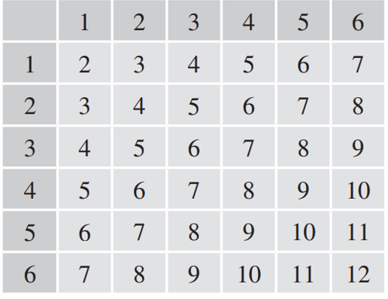
  - Draw a table showing the sample space if two dice are thrown in turn and their sum is recorded.

  - Highlight the reduced sample space if the sum of the two dice is 5.
The cases 1 + 4, 2 + 3, and 4 + 1 make up the reduced sample space
  - Given that the sum of the two dice is 5, what is the probability that:
    - the first die shows a 1,
$$only \left(1,4\right): \frac{1}{3}$$
    - at least one die shows a 1,
$$\left(1,4\right)and \left(4,1\right): \frac{1}{2}$$
    - at least one of the dice shows an odd number.
All outcomes in the reduced sample space have a odd number. $1$
- For two events A and B it is known that P(A∪B) = 0.6 and P(A) = 0.4 and P(B) = 0.3.
  - Use the addition formula P(A∪B) = P(A) + P(B) - P(A∩B) to find the probability
P(A∩B).
$$0.6 = 0.4 + 0.3 - P\left(A∩B\right)$$
$$P\left(A∩B\right)= 0.7 - 0.6 = 0.1$$
  - Use the formula for conditional probability to find P(A|B).

$$P\left(A | B\right)=\frac{P\left(A∩B\right)}{P\left(B\right)}=\frac{0.1}{0.3}=\frac{1}{3}$$
  - Find P(B|A).
$$P\left(B | A\right)=\frac{P\left(A∩B\right)}{P\left(A\right)}=\frac{0.1}{0.4}=\frac{1}{4}$$

  - Suppose that P(V∪W) = 0.7 and P(V) = 0.5 and P(W) = 0.35. Find P(V|W).
P(V∪W) = P(V) + P(W) - P(V∩W)
0.7 = 0.5 + 0.35 - P(V∩W)
P(V∩W) = 0.85 - 0.7 = 0.15
$$P\left(V | W\right)=\frac{P\left(V∩W\right)}{P\left(W\right)}=\frac{0.15}{0.35}=\frac{3}{7}$$
  - Find P(X|Y) if P(X∩Y) = 0.2 and P(X) = 0.3 and P(Y) = 0.4.
$$P\left(X | Y\right)=\frac{P\left(X∩Y\right)}{P\left(Y\right)}=\frac{0.2}{0.4}=\frac{1}{2}$$
  - Find P(A|B) if P(A∪B) = $\frac{1}{3}$ and P(A) = $\frac{1}{5}$ and P(B) = $\frac{3}{10}$.
$$P(A∪B) = P(A) + P(B) - P(A∩B)$$
$$\frac{1}{3}=\frac{1}{5}+\frac{3}{10}- P\left(A∩B\right)$$
$$P\left(A∩B\right)=\frac{1}{6}$$
$$P\left(A | B\right)=\frac{P\left(A∩B\right)}{P\left(B\right)}=\frac{\frac{1}{6}}{\frac{3}{10}}=\frac{5}{9}$$
- A cricket team knows that in half of the games they played last season, they won the game and their star player Arnav was playing. Arnav consistently plays in 80% of the games.
What is the probability that they will win this Saturday if Arnav is playing?

Find: P(W|A)
Let W = win, A = Arnav plays
Given: P(W∩A) = 0.5, P(A) = 0.8
$$P\left(W | A\right)=\frac{P\left(W∩A\right)}{P\left(A\right)}=\frac{0.5}{0.8}=62.5\%$$
- A card is drawn from a standard pack.
The dealer tells the players that it is a court card (jack, queen or king).
  - What is the probability that it is a jack?
4 jacks, 12 court cards
$$P\left(J | C\right)=\frac{4}{12}=\frac{1}{3}$$
  - What is the probability that it is either a jack or a red card?
P(J $∪$ R | C)
Jack or red court cards: 2 black jacks + 6 red court cards = 8
$$P =\frac{8}{12}=\frac{2}{3}$$
  - What is the probability that the next card drawn is a jack?
Assume that the first card was not replaced.

P(next card is jack | first was court card, not replaced)
Cards remaining: 51
If first card was jack: 3 jacks left
If first card was queen/king: 4 jacks left
P(first was jack | court) = 1/3
P(first was queen/king | court) = 2/3
P = (1/3)(3/51) + (2/3)(4/51) = 3/153 + 8/153 = 11/153

- A set of four cards contains two jacks, a queen and a king. Bob selects one card and then, without replacing it, selects another. Find the probability that:
  - both Bob's cards are jacks,

P(both jacks) = (2/4) × (1/3) = 2/12 = 1/6
  - at least one of Bob's cards is a jack,

P(at least one jack) = 1 - P(no jacks)
P(no jacks) = (2/4) × (1/3) = 2/12 = 1/6
P(at least one jack) = 1 - 1/6 = 5/6
  - given that one of Bob's cards is a jack, the other one is also a jack.

P(both jacks | at least one jack) = P(both jacks)/P(at least one jack) = (1/6)/(5/6) = 1/5

- A small committee of two is formed from a group of 4 boys and 8 girls.
If at least one of the members is a girl, what is the probability that both are girls?

A probability tree is useful here.
$$\frac{7}{15}$$

Mastery
- 2010 HSC Advanced Band 5
Events A and B are mutually exclusive events of a sample space with P(A) = p and P(B) = q where 0 < p < 1 and 0 < q < 1. P(A' ∩ B') is equal to:
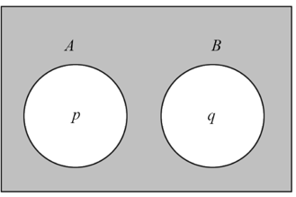
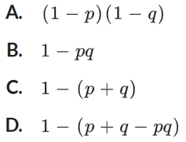

$$P(A'∩B') = 1 - P(A∪B) = 1 - \left[P\left(A\right)+ P\left(B\right)\right]$$
$$= 1 - \left(p + q\right)$$
$$C$$
- 2013 VCE Band 5
A and B are events of a sample space.
Given that $P(A|B) = p$, $P(B) = p²$ and $P\left(A\right)=\sqrt[3]{p},$ $P(B|A)$ is equal to
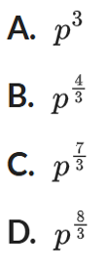
$$P\left(A | B\right)=\frac{P\left(A∩B\right)}{P\left(B\right)}$$
$$p =\frac{P\left(A∩B\right)}{p^{2}}$$
$$P(A∩B) = p^{3}$$
$$P\left(B | A\right)=\frac{P\left(A∩B\right)}{P\left(A\right)}=\frac{p^{3}}{p^{\frac{1}{3}}}= p^{3-\frac{1}{3}}= p^{\frac{8}{3}}$$
D

- 2020 HSC Advanced Band 5
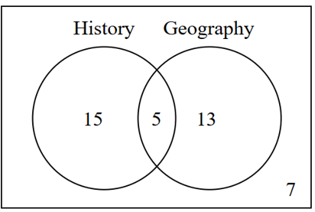
History and Geography are two subjects students may decide to study.
For a group of 40 students:
7 students study neither History nor Geography
20 students study History
18 students study Geography

  - Find the probability that the student studies both History and Geography.
$$\frac{5}{40}=\frac{1}{8}$$
  - Given that the student studies Geography, what is the probability that the student does NOT study History?
$$P\left(\bar{H} | G\right)=\frac{P\left(\bar{H}∩G\right)}{P\left(G\right)}=\frac{13}{18}$$
  - Two different students are chosen at random, one after the other. What is the probability that the first student studies History and the second student does NOT study History?

$$P\left(H, \bar{H}\right)= P\left(first studies H\right)× P\left(second doesn^{'}t study H\right)$$
$$= \left(\frac{20}{40}\right)× \left(\frac{20}{39}\right)=\frac{10}{39}$$
- 2009 VCE Band 5
Four identical balls are numbered 1, 2, 3 and 4 and put into a box. A ball is randomly drawn from the box, and not returned to the box. A second ball is then randomly drawn from the box.
  - What is the probability that the first ball drawn is numbered 4 and the second ball drawn is numbered 1?

$$P\left(4,1\right)= \left(\frac{1}{4}\right)× \left(\frac{1}{3}\right)=\frac{1}{12}$$
  - What is the probability that the sum of the numbers on the two balls is 5?

$$P\left(Sum = 5\right)$$
$$Favorable outcomes: (1,4), (2,3), (3,2), \left(4,1\right)$$
$$P =\frac{4}{12}=\frac{1}{3}$$
  - Given that the sum of the numbers on the two balls is 5, what is the probability that the second ball drawn is numbered 1?

$$P(2nd = 1 | Sum = 5)$$
$$Only \left(4,1\right) gives sum = 5 with second ball = 1$$
$$P =\frac{P\left(4,1\right)}{P\left(Sum = 5\right)}=\frac{\frac{1}{12}}{\frac{1}{3}}=\frac{1}{4}$$
- 2022 HSC Advanced Band 5
In a bag there are 3 six-sided dice. Two of the dice have faces marked 1, 2, 3, 4, 5, 6.
The other is a special die with faces marked 1, 2, 3, 5, 5, 5.
One die is randomly selected and tossed.
  - What is the probability that the die shows a 5?
  - Given that the die shows a 5, what is the probability that it is the special die?

A probability tree is useful here.
$$P\left(5\right)= \left(\frac{1}{3}\right)\left(\frac{1}{6}\right)+ \left(\frac{1}{3}\right)\left(\frac{1}{6}\right)+ \left(\frac{1}{3}\right)\left(\frac{3}{6}\right)$$
$$=\frac{5}{18}$$

$$P(special | 5 shown)=\frac{P\left(special ∩ 5\right)}{P\left(5\right)}=\frac{\frac{1}{3}×\frac{1}{2}}{\frac{5}{18}}= \frac{3}{5}$$

- 2017 VCE Band 5
For events A and B from a sample space, P(A|B) = $\frac{1}{5}$ and P(B|A) = $\frac{1}{4}$. Let P(A∩B) = $p$.
  - Find P(A) in terms of $p$.
$$P\left(A\right)=\frac{P\left(A∩B\right)}{P\left(B | A\right)}=\frac{p}{\frac{1}{4}}= 4p$$
  - Find P(A'∩B') in terms of $p$.
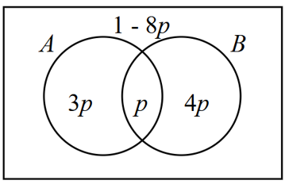

Using Venn diagram,
$$P\left(A^{'}∩B^{'}\right)= 1-8p$$
  - Given that $P\left(A∪B\right)≤$ $\frac{1}{5}$, state the largest possible interval for $p$.
$$P\left(A∪B\right)= 8p ≤\frac{1}{5}$$
$$∴ 0 < p ≤\frac{1}{40}$$

- 2024 VCE Band 5
At a Year 12 formal, 45% of the students travelled to the event in a hired limousine, while the remaining 55% were driven to the event by a parent.
Of the students who travelled in a hired limousine, 30% had a professional photo taken.
Of the students who were driven by a parent, 60% had a professional photo taken.
Given that a student had a professional photo taken, what is the probability that the student travelled to the event in a hired limousine?
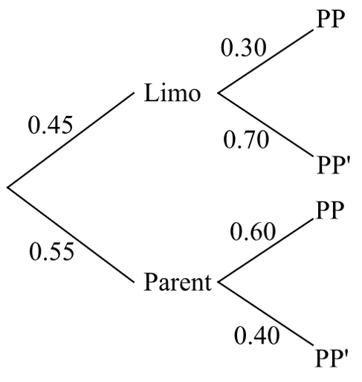

$$Pr\left(Limo | PP\right)=\frac{Pr\left(Limo ∩ PP\right)}{Pr\left(PP\right)}$$
$$=\frac{0.45 × 0.30}{\left[\left(0.45 × 0.30\right)+ \left(0.55 × 0.60\right)\right]}$$
$$=\frac{9}{31}$$

- 2023 HSC Advanced Band 6
Four Year 12 students want to organise a graduation party.
All four students have the same probability, P(F), of being available next Friday.
All four students have the same probability, P(S), of being available next Saturday.
It is given that P(F) = $\frac{3}{10}$, P(S|F) = $\frac{1}{3}$, and P(F|S) = $\frac{1}{8}$.
Kim is one of the four students.
  - Is Kim's availability next Friday independent from his availability next Saturday?
Justify your answer.
  - Show that the probability that Kim is available next Saturday is 4/5.
  - What is the probability that at least one of the four students is NOT available next Saturday?

a) For independence: P(F) = P(F|S)
$$\frac{3}{10}≠\frac{1}{8}$$
∴ Not independent

$$b) P\left(S | F\right)=\frac{P\left(S∩F\right)}{P\left(F\right)}$$
$$\frac{1}{3}=\frac{P\left(S∩F\right)}{\frac{3}{10}}$$
$$P\left(S∩F\right)=\frac{1}{10}$$
$$P\left(F | S\right)=\frac{P\left(S∩F\right)}{P\left(S\right)}$$
$$\frac{1}{8}=\frac{\frac{1}{10}}{P\left(S\right)}$$
$$P\left(S\right)= \left(\frac{1}{10}\right)× 8 =\frac{4}{5}$$

c) P(at least 1 not available) = 1 - P(all 4 available)
$$= 1 - {\left(\frac{4}{5}\right)}^{4}= 1 -\frac{256}{625}$$
$$=\frac{369}{625}$$

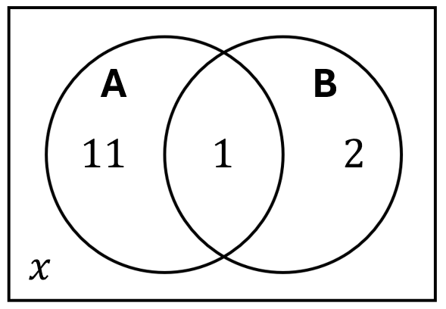
- The two events $A$ and $B$ are known to be independent.
Find the value of $x$ by setting up and solving the equation:
- $P\left(A\right)×P\left(B\right)=P\left(A∩B\right)$  $$\frac{12}{14+x}×\frac{3}{14+x}=\frac{1}{14+x}$$  $$∴x=22$$ | - $P\left(A | B\right)=P\left(A\right)$  $$\frac{1}{3}=\frac{12}{14+x}$$  $$∴x=22$$

